Clean

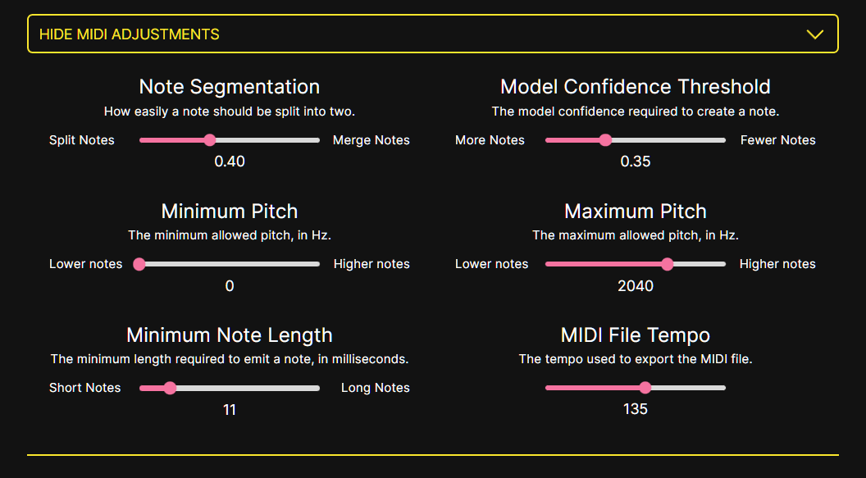More pitch at the cost of accuracy with note start and end times

All the notes (virtually no info on start and end times of a note and a lot more garbage, but better detection)

